Computers use binary numbers internally. A character is stored in a computer as a sequence of 0s and 1s. Mapping a character to its binary representation is called encoding. There are different ways to encode a character. How characters are encoded is defined by an encoding scheme.

Java supports Unicode, an encoding scheme established by the Unicode Consortium to support the interchange, processing, and display of written texts in the world’s diverse languages. Unicode was originally designed as a 16-bit character encoding. The primitive data type char was intended to take advantage of this design by providing a simple data type that could hold any character. However, it turned out that the 65,536 characters possible in a 16-bit encoding are not sufficient to represent all the characters in the world. The Unicode standard therefore has been extended to allow up to 1,112,064 characters. Those characters that go beyond the original 16-bit limit are called supplementary characters. Java supports the supplementary characters. The processing and representing of supplementary characters are beyond the scope of this book. For simplicity, this book considers only the original 16-bit Unicode characters. These characters can be stored in a char type variable.

A 16-bit Unicode takes two bytes, preceded by \u, expressed in four hexadecimal digits that run from \u0000 to \uFFFF. Hexadecimal numbers are introduced in Appendix F, Number Systems. For example, the English word welcome is translated into Chinese using two characters 欢迎. The Unicodes of these two characters are \u6B22\u8FCE. The Unicodes for the Greek letters α β γ are \u03b1 \u03b2 \u03b3 respectively.

Most computers use ASCII (American Standard Code for Information Interchange), an 8-bit encoding scheme, for representing all uppercase and lowercase letters, digits, punctuation marks, and control characters. Unicode includes ASCII code, with \u0000 to \u007F corresponding to the 128 ASCII characters. Table 4.4 shows the ASCII code for some commonly used characters. Appendix B, “The ASCII Character Set,” gives a complete list of ASCII characters and their decimal and hexadecimal codes.
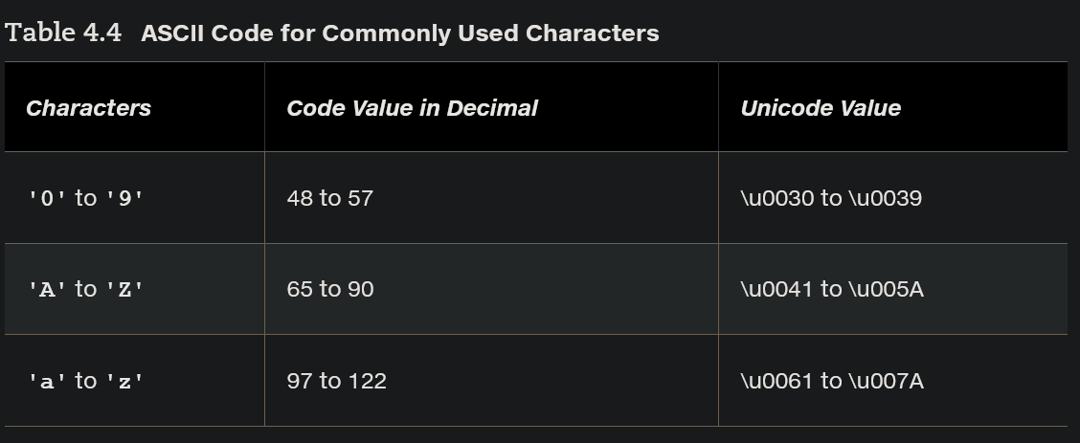
You can use ASCII characters such as 'X', '1', and '$' in a Java program as well as Unicodes. Thus, for example, the following statements are equivalent:
char letter = 'A';
char letter = '\u0041'; // Character A’s Unicode is 0041
Both statements assign character A to the char variable letter.
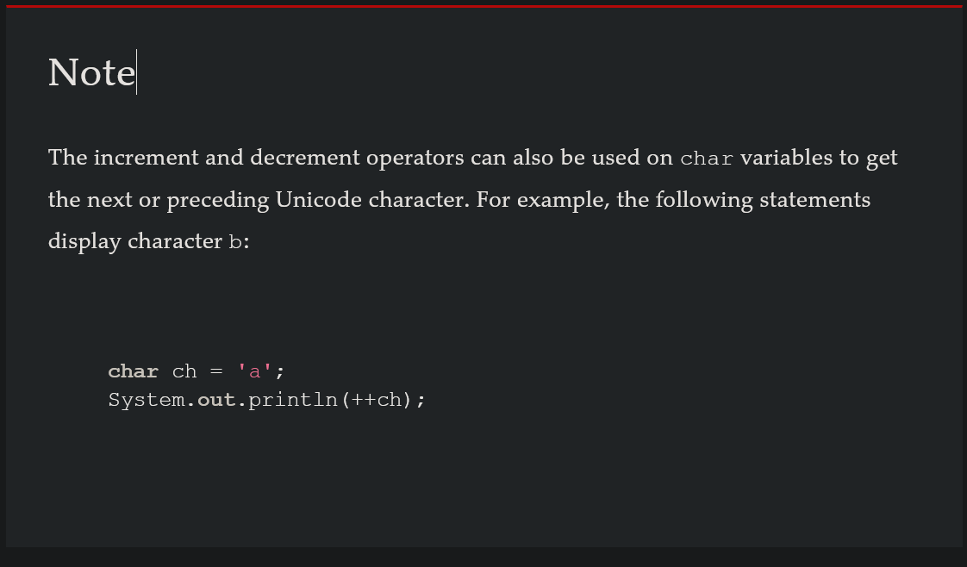
Appendix F: Number Systems
F.1: Introduction
Computers use binary numbers internally, because computers are made naturally to store and process 0s and 1s. The binary number system has two digits, 0 and 1. A number or character is stored as a sequence of 0s and 1s. Each 0 or 1 is called a bit (binary digit).
In our daily life, we use decimal numbers. When we write a number such as 20 in a program, it is assumed to be a decimal number. Internally, computer software is used to convert decimal numbers into binary numbers, and vice versa.
We write computer programs using decimal numbers. However, to deal with an operating system, we need to reach down to the “machine level” by using binary numbers. Binary numbers tend to be very long and cumbersome. Often hexadecimal numbers are used to abbreviate them, with each hexadecimal digit representing four binary digits. The hexadecimal number system has 16 digits: 0–9 and A–F. The letters A, B, C, D, E, and F correspond to the decimal numbers 10, 11, 12, 13, 14, and 15.
The digits in the decimal number system are 0, 1, 2, 3, 4, 5, 6, 7, 8, and 9. A decimal number is represented by a sequence of one or more of these digits. The value that each digit represents depends on its position, which denotes an integral power of 10. For example, the digits 7, 4, 2, and 3 in decimal number 7423 represent 7000, 400, 20, and 3, respectively, as shown below:
The figure illustrates an interactive showing the decimal number 7423 as the sum of its position values.
F.1-1 Full Alternative Text
The decimal number system has 10 digits, and the position values are integral powers of 10. We say that 10 is the base or radix of the decimal number system. Similarly, since the binary number system has two digits, its base is 2, and since the hex number system has 16 digits, its base is 16.
If 1101 is a binary number, the digits 1, 1, 0, and 1 represent respectively:
The figure illustrates an interactive showing the binary number 1 1 0 1 as the sum of its position values.
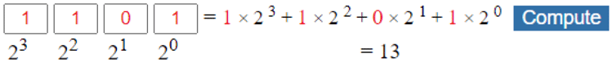F.1-2 Full Alternative Text
If 7423 is a hex number, the digits 7, 4, 2, and 3 represent respectively:
The figure illustrates an interactive showing the hex number 7423 as the sum of its position values.
F.1-3 Full Alternative Text

